Assignment – 1

ACADEMIC SESSION 2020/2021

DR PROF MADYA DR. NURUL HASHIMAH AHAMED HASSAIN MALIM

Year-1

ANJUMANARA ATHINA

Matric No: 155142

**1.Problem Analysis(Input, Output, Process and Constraints)**

**Input :**

choose a table to practice

choose an option from the menu

choose either you try again or you exit

exit option

**Process :**

Determine to display 10 times tables and checking answer of 5 random questions and using formula of (totalmark = totalmark + mark) and ( score =(totalmark/25)*100)

**Output** :

10times table and 5 random questions on 10 times tables and checking answer.

**Constraints :**

you can only choose one of the three options

you can only choose table from 1 to 10

you can either try again or exit and you can not try again in 10 times table

you can not have more than or less than 5 questions for every exam

2. Algorithm (Pseudocode and Flow Chart)

Pseudocode :

1. write the multiplication tables definition and the options.

2. make the user choose an option.

3. create three options: the 10 times table, a table to practice, exam.

4. when the user chooses a table to practice make the user choose a table from 1 to 10

5. display the table that the user has chosen

6. when the user chooses the 10 times table display the 10 times table.

7. when the user chooses the exam display 5 random questions and make the user answer it.

8. compare the true answers with the user answers

9. for every true answer give 5 marks and null for the wrong one.

10. calculate and display the total score and the percentage.

Flowchart

Print”WELCOME TO MULTIPLICATION TABLE”

Print "Enter 1 to display specific Time table", " Enter 2 to Display all 10 Times Table", "Enter 3 to Test Yourself with 5 random Multiplication questions"

Read choice

Print “Enter Your Choice of Time table that you wish to learn = ”

Step 1

true

Read timetable

I<= 10

I =i+1

I = 1

true

Print counter, “ * ” , timetable “ = ” , table

Table = timetable*counter

Step 3

totalmark = 0

i = 0

i < 5

false

random1= (rand() % 10 + 1) random2= (rand() % 10 + 1) answer= random1 * random2

true

Answer= useranswer

true

Mark=5

false

mark = 0

Print”the ans is correct”

totalmark=totalmark + mark

i = i + 1

Print “You Did not Enter choice 1 , 2 or 3 " , "Please

enter a Valid choice if you wish to proceed "

Print “If yes Enter Y to proceed or Enter any key to quit the program "

Read option

option = ‘Y’ || option= ‘y’

true

Print”Thank you”

**3.Implementation(C++ Program)**

Refer to Athina.cpp

**4. Test cases (Screenshots for the test cases)**

Main menu

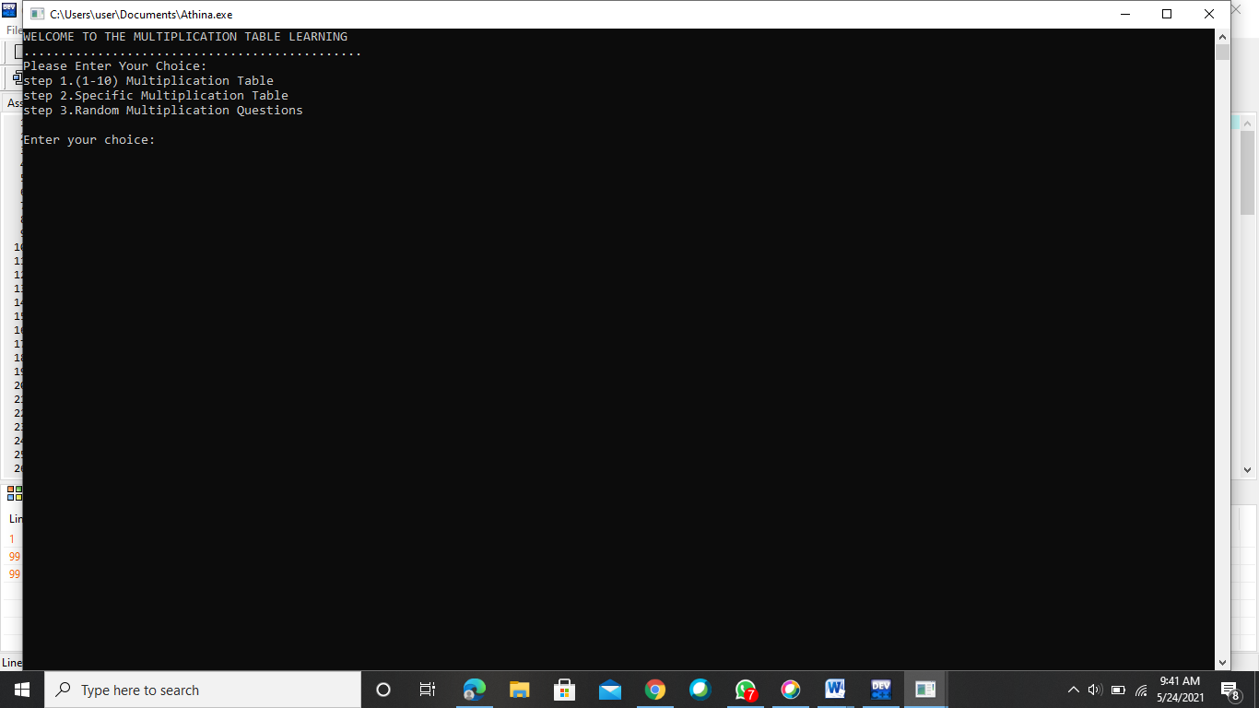

Step-1

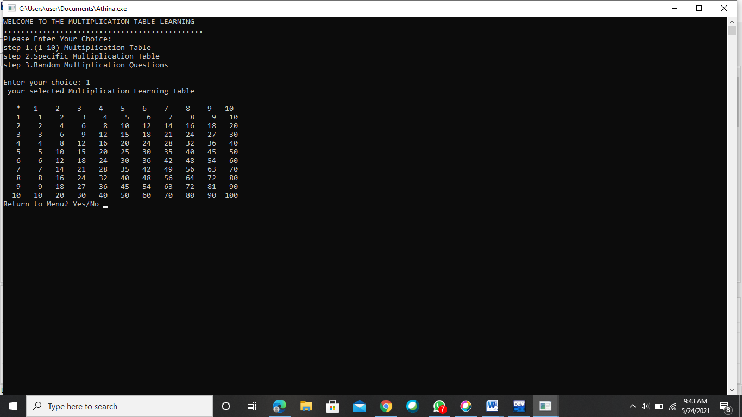

Step-2

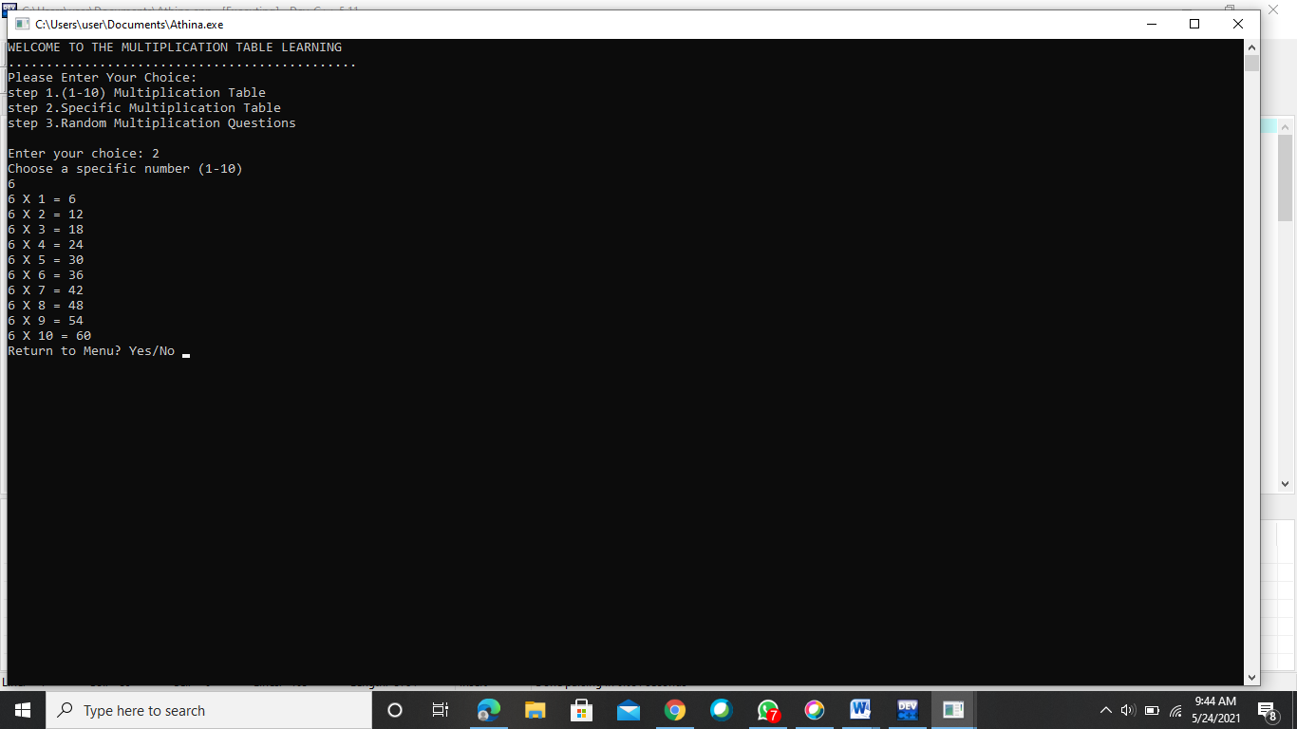

Step-3

